Role and Significance of CRM in view of Commercial Banking Sector
A study in the context of Saudi Arabia
Dr Syed Mohammad Akmal¹
Assistant Professor, Department of E-Commerce
Saudi Electronic University, Saudi Arabia

Dr Syed Mohammad Faisal²
Assistant Professor, Department of Business Management
Jazan University, Saudi Arabia

Dr Ahmad Khalid Khan3
Assistant Professor, Department of Business Management
Jazan University, Saudi Arabia

Abstract :-
This research paper aims at providing role and significance of Customer Relationship Management (CRM) specifically in the banking sector in Kingdom of Saudi Arabia, Riyadh region. Researchers have tried their best to cope up challenges and hurdles during primary data collection that is entirely based on questionnaire in two sections to meet all criterion as well as requirements of respondents from banking sectors alone. During our study we have noticed that ,CRM systems are the new trend in the banking sector of Saudi Arabia as the country is going to a transition period the government have initiated an optimistic vision of 2030.
The government aims at reducing the dependence on oil income and to have a more diversified economy in near future as compatible with its vision. The plan include a new tax regulations and reduce the government sector in favor of the supporting the private sector. Based on that, the competition on the banking sector increased as the market liquidity shrunk due to the cut on the government expenditure.
Then banks started to use professional tools and systems to attract and sustain their customer base using state of the art technology and utilize more resources to maintain a steady profit flow. From this point, CRM systems become a necessity for banks to accomplish their goals.
KEY WORDS :-
CRM, banking, Customers, Management
=======================================================
LITERATURE REVIEW:-
Abdullah S. Al-Mudimigh. (2009). CRM scorecard-based management system: Performance evaluation of Saudi Arabian banks. Journal of Digital Asset Management (2009) 5, 347 – 351, the paper proposes a CRM scorecard to evaluate, measure and enhance CRM system in Saudi banks. The evaluation includes the bank strategy and performance on regard of business solutions development also, measuring the Saudi Arabian banks CRM practices. The scorecard Translating vision and strategy through four perspectives which are Financial, Customer, Internal Business Process and Learning and Growth. The paper assume that CRM systems will fail without a proper management tools to assess and measure the effectiveness of the CRM and the suggested scorecard will help in providing an accurate measurement of CRM effectiveness.
Eid, Riyad. (2007). Towards a Successful CRM Implementation in Banks: An Integrated Model. The Service industries journal. ISSN: 0264-2069. 12/01/2007. Volume: 27 Issue: 8 Page: 1021-1039. The paper tries to identify the rule of CRM in the banking sector and its implications on customers relationship from the prospective of marketing activates incited by using CRM systems in 159 banks. The study found that CRM have substantial positive results of CRM usage in both the effectiveness of users and the marketing objectives and that would be achievable by implementing the CRM system holistically to reach and achieve the full potential of it rather than a piecemeal implementation which will not have the same level of success. Also, as the CRM implementation success level as the role it will be reflected on customer relationship quality and satisfaction.
Joseph Vella, Albert Caruana, (2012) "Encouraging CRM systems usage: a study among bank managers", Management Research Review, Vol. 35 Issue: 2, pp.121-133, the study aims to understand the main purpose of banks managers to use CRM systems and to test the usefulness of the CRM systems in encouraging users. The writers developed a hypothesis of the variables between the usefulness of CRM in motivating the perceives intentions of use of CRM and data been collected from management level participants from the banking sector. The results showed that as the perceived ease of CRM system usage as the intentions are higher which increase the levels of management adoption of CRM systems.
Al-Refaie, A., Tahat, M. D., & Bata, N. (2014). CRM/e-CRM Effects on Banks Performance and Customer-Bank Relationship Quality. International Journal of Enterprise Information Systems (IJEIS), 10(2), 62-80. The study tries to examine the impact of CRM system on Jordanian banks. The method used is a structural equation modeling. the study included 14 banks to measure the influence of CRM and e-CRM on those banks from the prospective of relationship quality, customer based-service attributes and customer life time value.
Patwa, L.K., & Patwa, K.K. (2014). An Analytical Study of CRM Practices in Public and Private Sector Banks in the State of Uttar Pradesh. Pacific business review international, 6(7), 60-69, measure the performance of relative CRM and examine its effect in increasing customer satisfaction and retention in both private sector and public-sector banks of an Indian district called Uttar Pradesh. The study used a stratified random sampling method from 4 banks two of them are private and the other two are public. The study size sample was 328 in total respondents. The examination showed that the private sector banks have a more effective CRM implementation compared to the public banks. The study reviles from a strategic point of view that innovation, customer understanding and building better relationship with customers are more efficient in private banks. Within the two sectors private and public the CRM have an equal effect on them due to the market competition level yet the utilization level of the CRM varies between the sectors which should build and sustain a stronger customer relationship and higher satisfaction.
Kumaraswamy, M., & Jayaprasad, D. (2014). Customer Relationship Management in Kaveri Grameena Bank. GIRA - global journal for research analysis, 3(2), 29-34, the study toke place in one bank which is Kaveri Grameena Bank. The aim of the study is measuring the gap between the banking service level and the customer expectation and the effect of CRM strategies on narrowing this gap. The collection of research primary data was through interaction, administrated questionnaires and observation. The sample was selected randomly with a total size of 100 respondents and also secondary data, reports, statistical figures and government published data. The results show that the customer satisfaction is high due to the banks efforts in keeping up to date technological options with the highest level of services and investment opportunities which make bank services up to their expectations including the banks utilization of electronic banking services to provide customers with smooth e-banking experience. The study concluded that there still a lack of adoption of technology and that hinder the bank form attracting more customers compared to the competitors in the market.
Selvakumar Marimuthu, Ramar Lakshmanan, Sathyalakshmi Veluchamy. (2016). Analysis of E-CRM Services of Banks: from the View of Bankers. Acta Universitatis Danubius. Vol. 12, no. 6, pp. 134-159. the aim of this paper is to study the e-CRM services in the banks of Virudhunagar district in India from the view point of the banks employees. That data gathered the employees’ opinions during 2014 with following a descriptive and analytical methods primarily from bank officials with total participants of 83 including interview schedule and questionnaire. Moreover, the paper secondary data collected from the banks published information and records. The study found out that the banks of the subject study receive low number of e-CRM compliance but all those compliance due to the lack of customer segmentation accuracy in the CRM. Also, the time spent to solve any customer inquiries takes a period of 5 to 10 minutes.
The project survey aims to measure the awareness, acceptance and adoption levels of front desk RMs who deal directly with clients on their daily tasks on regard of implementing Customer Relationship Management (CRM) system in the organization. Moreover, to define some of the expected limits of using CRM system. The survey was designed using Google forms application and distributed electronically to the potential population of interest.
SURVEY DISCUSSION:
We will discuss each subject result with including a chart for each question to demonstrate the responses based on proportion of scale in percentage. The total precipitance in the survey ware 82 Relationship Manager (RM) representing 12.18 % from a total population of 673 RMs in corporate and treasury sectors who deal directly with clients on their daily tasks other RMs in the same sectors are not included. Moreover, retail RMs are not included as they deal directly with retail customers (individuals) including the High Net Wealth (HNW) clients.

PART 1: GENERAL INFORMATION:
Age? | 18-24 | 25-34 | 35-44 | 45-54 | More
Age? | 4.70% | 71.20% | 21.50% | 2.40% | 0%
- Age:
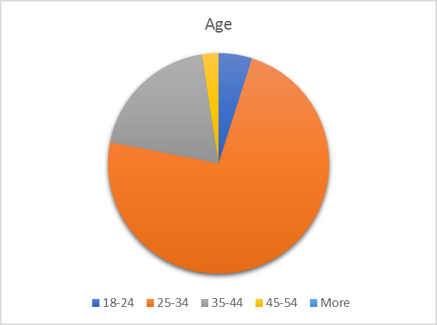
The majority of the participants were between 25-34 years while the age range 35-44 is less. This indicates that the RMs who interact with corporate customers are young and that should result in higher activity and accomplishment levels. Moreover, it also indicates that the participants are in range of age were new ideas and concepts be highly accepted and adopted to support their carrier and improve their experience.
- Education level:
Education level? | High School | Diploma | Bachelor Degree | Graduate Degree | Other
Education level? | 2.30% | 4.90% | 44.90% | 47.80% | 0%

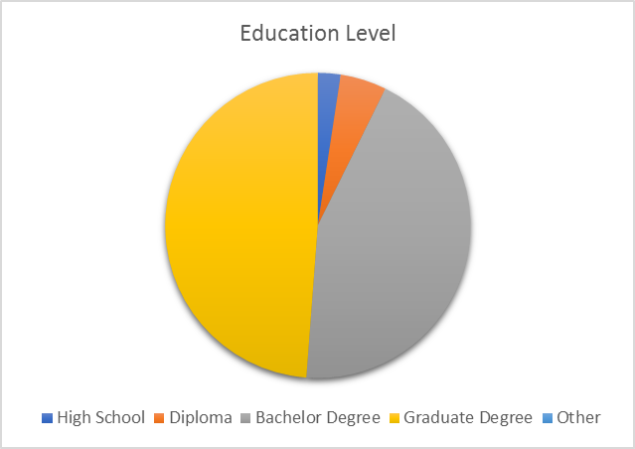
The level of education reflects that the participants highly educated and that may result from the government program of international scholarship as the government expanded the program at early years of 2000s. It indicates that the participants might have the high level of understanding and adoption for the CRM as concept and system.

- Years of experience:
Years of experience? | 1-5 | 6-10 | 11-15 | 16-20 | More
Years of experience? | 37.60% | 41.50% | 12.20% | 8.80% | 0%
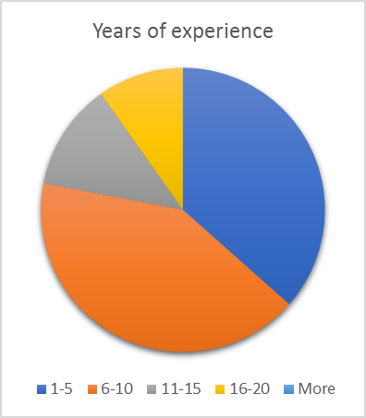
The years of experience of the participants are ranged mainly between 1 year to 10 years which can be linked to the results in age and education level. That indicates that the participants are at good level of experience which can improve the level of understanding for the CRM aspects.
Position level:
Position level? | Junior | Intermediate | Senior | Lead
Position level? | 5.30% | 52.20% | 38% | 5.30%
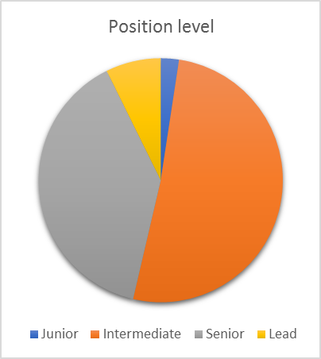
This indicates that the participants have a level of dependent decision making when dealing with customers. Usually intermediate and Senior level RMs in the banking sector have room to improve the quality of service provided to customers by for example reducing the services fees to predetermined level by management to give the Relationship Manager (RM) the power to attract and sustain the relationship with the customers.

- Gender:
Gender? | Male | Female
Gender? | 100% | 0%
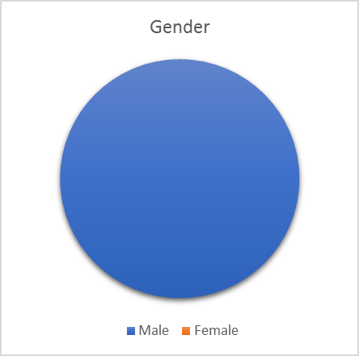
Kindly note that due to the lack of support from the bank management the survey was not distributed through the bank official internal communication channels. The survey was distributed based on personal relationships with the other RMs which limited the participation gender to be male only.
PART 2: SURVEY SUBJECTS:
- Knowledge:
Scale | Strongly Agree | Agree | Neutral | Disagree | Strongly Disagree
1. You have a strong knowledge about the concept of CRM? | 17.10% | 53.70% | 19.50% | 9.80% | 0%
2. You have a strong knowledge about CRM systems? | 14.60% | 41.50% | 24.40% | 19.50% | 0%
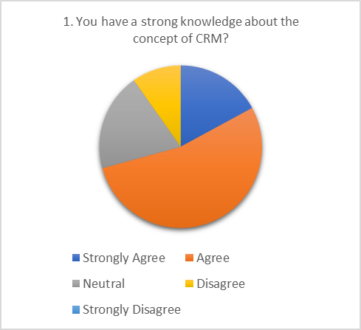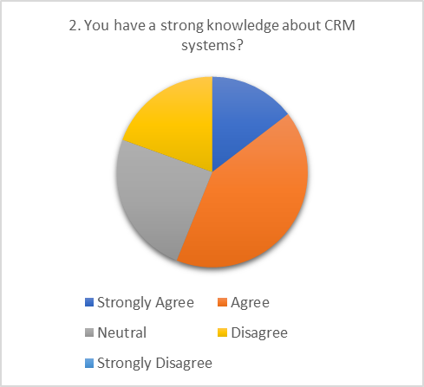
More than half of the participants have a knowledge and used a CRM system before. That indicates that the bank will have to make the CRM system introduction more detailed and short in period as there were previous experience and knowledge about CRM concept.

- Acceptance:
Scale | Strongly Agree | Agree | Neutral | Disagree | Strongly Disagree
3. You have used a CRM system before? | 19.50% | 36.60% | 12.20% | 29.30% | 2.40%
4. You agree to use a CRM system in your daily tasks? | 24.40% | 53.70% | 12.20% | 7.30% | 2.40%
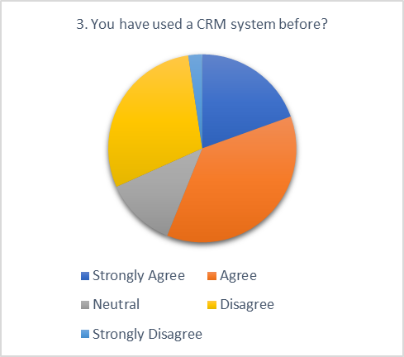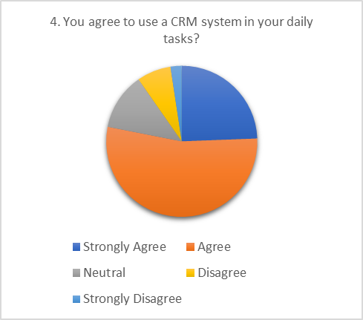
53.7 % of the participants agree to use CRM system in their daily tasks while 57 % of them have used one before and that indicates the high acceptance level as 88 % of them in the agree area. This positive feedback will help management to increase the RMs involvement in CRM adoption.
- Sharing:
Scale | Strongly Agree | Agree | Neutral | Disagree | Strongly Disagree
5. You will share your clients’ information with other departments through the CRM system? | 22% | 34.10% | 26.80% | 14.60% | 2.40%
6. You will share your clients’ interests with other departments through the CRM system? | 29.30% | 36.60% | 17.10% | 14.60% | 2.40%
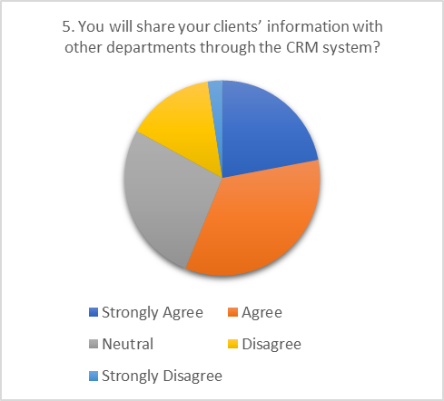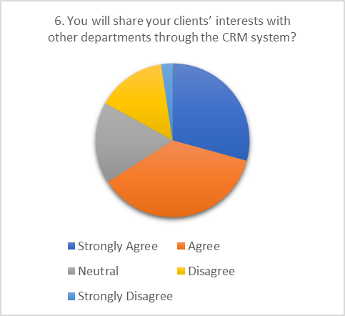
Losing a customer is the nightmare of any bank RM so they tend to keep the customers data for themselves or only shared among the department level. The data shows that the participants willingness to share their customers' data and interests is high as they expect the CRM system keep tracking the customers activates and provide them with the best possible solutions to maximize the customers satisfaction.
- Customer loyalty and satisfaction:
Scale | Strongly Agree | Agree | Neutral | Disagree | Strongly Disagree
8. CRM can help increase your existing clients’ loyalty? | 31.70% | 43.90% | 20.50% | 3.90% | 0%
9. CRM can improve your clients’ satisfaction? | 31.70% | 45.30% | 19.50% | 3.40% | 0%
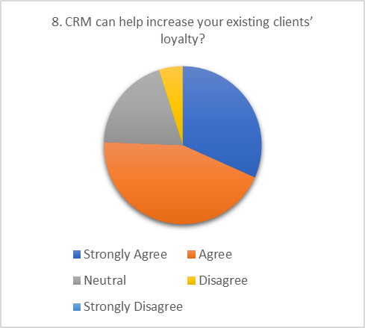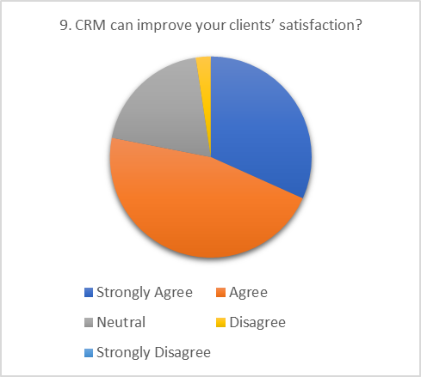
Sustain a strong customer relationship and keeping a constant lending and browning activates give banks a steady flow of profit making activates and that’s why banks employ RMs. Having a great believe on the CRM ability to create a strong customer loyalty reflected on the agree zone with total of 75 % believe in loyalty increase and an improve of satisfaction by 78 % in the agree zone
- Performance:
Scale | Strongly Agree | Agree | Neutral | Disagree | Strongly Disagree
7. CRM can measure your performance? | 18.50% | 47.30% | 17.10% | 14.60% | 2.40%
13. CRM can improve your efficiency in doing the daily work tasks? | 41% | 38% | 19 | 3.40% | 0%
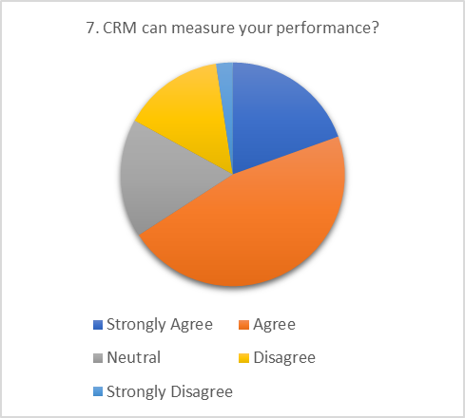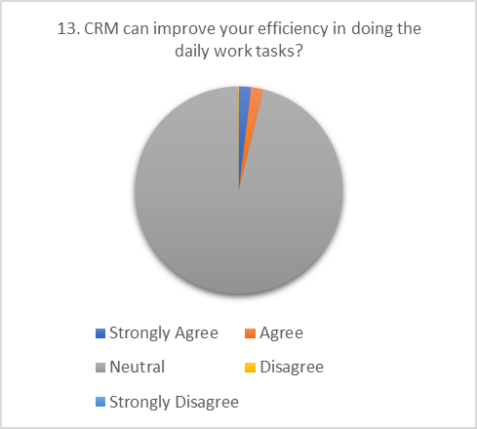
Performance measurement is a major factor that help RM in their daily tasks. With saving their time from doing redundant efforts to record or document any customer related issues RMs will have more time to service and communicate with other customers.
- Key performance indicators (KPI):
Scale | Strongly Agree | Agree | Neutral | Disagree | Strongly Disagree
11. CRM can help in expand your client base? | 31.70% | 41.50% | 24.40% | 2.40% | 0%
12. CRM can enhance your progress in achieving your targets? | 36.60% | 41.50% | 22% | 0% | 0%
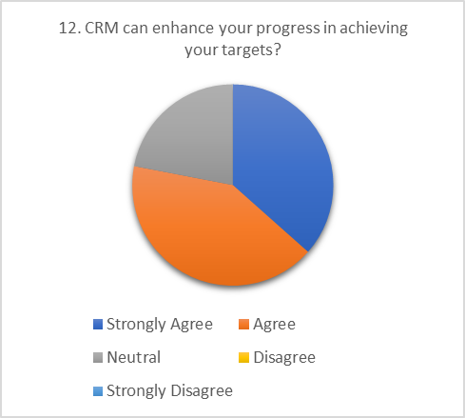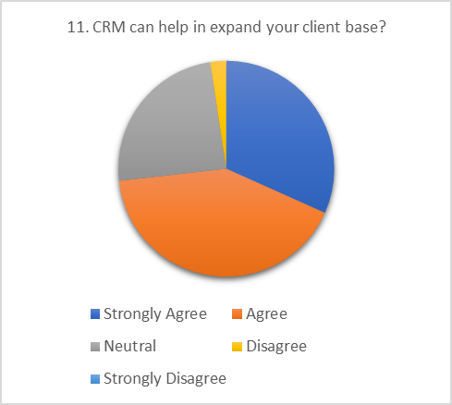
Increasing the customers base is the first target set by management to any RM. A new customer means new source of profit or at least a new volume of free cash in the current account. CRM gathers data which turns to knowledge which will be utilized by RMs to new customers and new opportunities with current customers. 73 % participants on the agree zone that CRM will help in increasing their customers base through automation and data utilization Moreover, achieving their primary targets set by management during the year with 78 % agree level in the CRM ability to support that.
- Cross sell:
Scale | Strongly Agree | Agree | Neutral | Disagree | Strongly Disagree
10. CRM can help in defining new opportunities for your existing clients? | 34.10% | 46.30% | 17.10% | 2.40% | 0%
15. CRM can motivate you to make more cross sell initiatives with other departments? | 29.30% | 51.20% | 19.50% | 0% | 0%
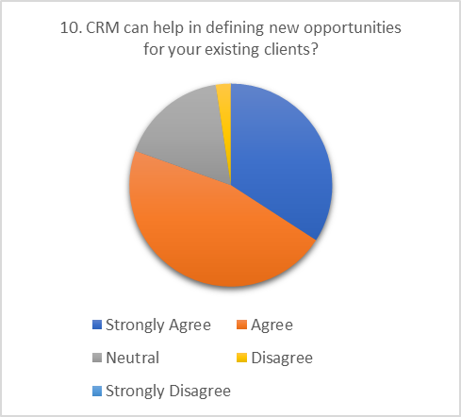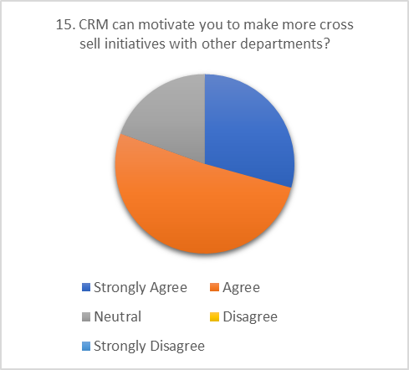

The concept of cross sell represents the joint efforts of RMs from different departments in marketing their departments services to one customer on a single visit. Utilizing the CRM capabilities to initiate cross sell initiatives will help in saving times and reduce the efforts to reach the same client in several meetings to achieve the same result. Having a trust on the CRM in defining new opportunities with more than 80 % agree level by participants and the same level on CRM ability to motivate RMs for more cross sell initiatives.

- Comprehension:
Scale | Strongly Agree | Agree | Neutral | Disagree | Strongly Disagree
14. CRM can provide all the necessary information about clients? | 34.10% | 51.20% | 12.20% | 2.40% | 0%
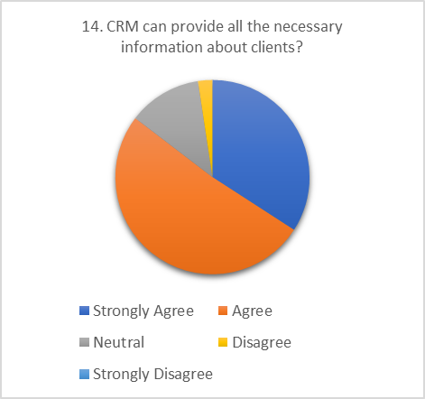
Knowledge management is one core function in the CRM system which help in gathering, analyzing the customers information and date. 85 % of the participants agree on the CRM ability to store and provide the customer necessary information. That indicates the level of the RM dependence on the CRM system in the future when the CRM system will be fully implemented.
- Conflict of interest:
Scale | Strongly Agree | Agree | Neutral | Disagree | Strongly Disagree
16. CRM can expose sensitive information about your clients to other departments? | 22% | 36.60% | 17.10% | 24.40% | 0%
17. CRM can make you lose clients in favor to other departments? | 4.90% | 31.70% | 24.40% | 26.80% | 12.20%
18. CRM can create a conflict of interest between departments? | 7.30% | 39.00% | 12.20% | 31.70% | 9.80%
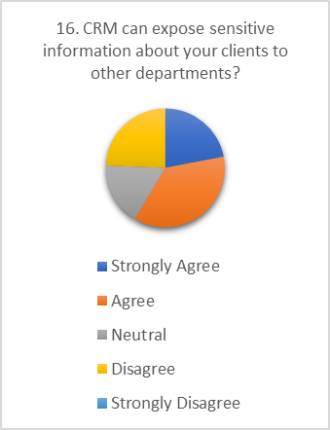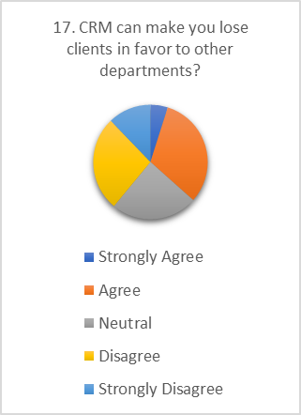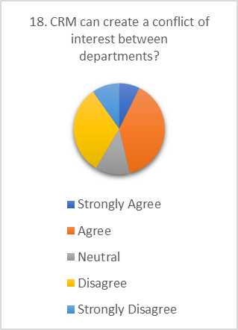
Banks are known for their high level political and conflict of interest environments. Due to that banks losses great opportunities every day as things become complicated between departments. The conflicts started when a profit source opens to the bank and each department seek to record that in their achievement list. Usually banks have internal agreement for Fund Transfer Pricing (FTP) to segregate the profit and allocate it to the subject department but, that doesn’t always apply.
- Profit / Loss:
Scale | Strongly Agree | Agree | Neutral | Disagree | Strongly Disagree
19. CRM can help in increasing the organization profits? | 29.30% | 53.70% | 14.60% | 2.40% | 0%
20. CRM can help in decreasing the organization costs? | 17.10% | 53.70% | 24.40% | 4.90% | 0%
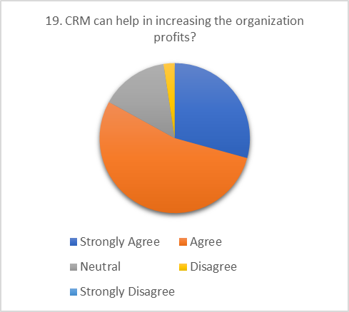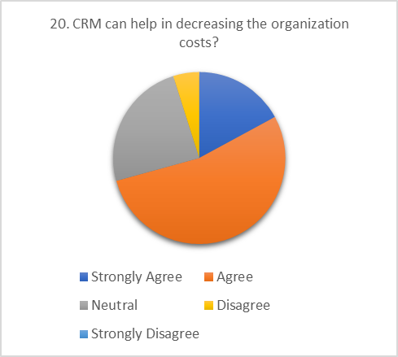
The agree level is high in both areas of profit generation and cost reduction resulted from implementing CRM system. The perception is high with 83 % agree level on profit taking and 70 % in cost reduction. This will help management to enforce the utilization of CRM among all related departments to achieve the momentum of the CRM system and to compensate for its high implementation and customization cost.
LIMITATIONS OF STUDY:-
- The bank management refused the request to distribute the survey through the official internal channels and that hindered the survey reach to more of the population of interest.
- Due to the lack of official approval to communicate the survey to the population of interest it only reached part of the male prospective participants with no female participants.
- The survey subjects are huge and can’t be covered in a single paper in such short time yet it need more time and effort to make more accurate, detailed and comprehensive results and then it will be suitable to publish in scientific journals moreover to add to the banking sector in Saudi Arabia.
CONCLUSION REPORT:-
Out of our questionnaire prepared for banking employees in Saudi Arabia , researchers have carefully monitored and reviewed responses from employees to justify their data analysis as mentioned aforesaid survey report along with all figures and facts and reached at conclusion as mentioned below.
There is a big chance for the CRM success in the bank and the employee’s adoption to the CRM is high in prospective level. The survey shows a high level on knowledge and acceptance for CRM but no clear results regarding the resolve of the conflict of interest between the departments. CRM system will be a great tool for the bank to gather, analyze, create reports and defining opportunities. CRM abilities and capabilities are highly trusted to give a comprehensive view and reports in the knowledge management aspect. The utilization levels of CRM system function will help the bank increase the constant profit opportunities and reduce the cost consuming items and redundancy to save cost.

REFERENCES :-
Abdullah S. Al-Mudimigh. (2009). CRM scorecard-based management system: Performance evaluation of Saudi Arabian banks. Journal of Digital Asset Management (2009) 5, 347 – 351.
Accenture.(2007). Global Customer Satisfaction Survey. Customer Satisfaction in the Changing Economy
Al-Refaie, A., Tahat, M. D., & Bata, N. (2014). CRM/e-CRM Effects on Banks Performance and Customer-Bank Relationship Quality. International Journal of Enterprise Information Systems (IJEIS), 10(2), 62-80.
Anthony Larsson, Yamit Viitaoja, (2017) "Building customer loyalty in digital banking: A study of bank staff’s perspectives on the challenges of digital CRM and loyalty", International Journal of Bank Marketing, Vol. 35 Issue: 6, pp.858-877.
Balakrishnan, H., & Krishnaveni, R. (2014). A Study on Customer Relationship Management Practices in Selected Banks with Reference to Coimbatore District. The SIJ Transactions on Industrial, Financial & Business Management (IFBM), 2(1), 15-20
Bharadwaj, A. S. (2000). A resource-based perspective on information technology capability and firm performance: An empirical investigation. MIS Quarterly, 24 (1), 169–196. doi:10.2307/3250983
Blery, E., & Michalakopoulos, M. (2006). Customer relationship management: A case study of a Greek bank. Journal of Financial Services Marketing, 11(2), 116– 124. doi:10.1057
Bohling, T., Bowman, D., LaValle, S., Mittal, V., Narayandas, D., Ramani, G., & Varadarajan, R. (2006). CRM implementation: Effectiveness issues and insights. Journal of Services Research, 9(2), 184–194. doi:10.1177/1094670506293573
Boru, T. (2014). The determinants of Ethiopian commercial banks performance. European Journal of Business and Management, 6(14), 52-62.
Colgate, M., & Norris, M. (2001). Developing a comprehensive picture of service failure. International Journal of Service Industry Management, 12(3/4), 215–234. Doi:10.1108/09564230110393211
Eid, Riyad. (2007). Towards a Successful CRM Implementation in Banks: An Integrated Model. The Service industries journal. ISSN: 0264-2069. 12/01/2007. Volume: 27 Issue: 8 Page: 1021-1039.
Joseph Vella, Albert Caruana, (2012) "Encouraging CRM systems usage: a study among bank managers", Management Research Review, Vol. 35 Issue: 2, pp.121-133
Kotler, Philip, & Armstrang, Gary.Principles of Marketing.New Delhi: Pearson Education Limited
Kumaraswamy, M., & Jayaprasad, D. (2014). Customer Relationship Management in Kaveri Grameena Bank. GIRA - global journal for research analysis, 3(2), 29-34
Mylonakis, J. (2009). Customer relationship management functions: A survey of Greek bank customer satisfaction perceptions. ICFAI Univ. Journal of Bank Management,VIII (2), 7-31.
Patwa, L.K., & Patwa, K.K. (2014). An Analytical Study of CRM Practices in Public and Private Sector Banks in the State of Uttar Pradesh. Pacific business review international, 6(7), 60-69.
Selvakumar Marimuthu, Ramar Lakshmanan, Sathyalakshmi Veluchamy. (2016). Analysis of E-CRM Services of Banks: from the View of Bankers. Acta Universitatis Danubius. Vol. 12, no. 6, pp. 134-159.

