**Benchmarking and Enhancing the Wheat Value Chain in Central Ethiopia: A Comparative Assessment with Global Best Practices**

Abraham Ababiya1*, Kacha Assefa2, Yisihak Ergicho3

1Department of Agricultural Economics, College of Agricultural Science, Wachemo University, Ethiopia.

2&3Department of Economics, College of Business and Economics, Wachemo University, Ethiopia

* Corresponding Author: [abrahamababiya2@gmail.com](mailto:abrahamababiya2@gmail.com)

|  |  |
| --- | --- |
|  | **ABSTRACT** |
|  | *This study presents a comprehensive evaluation of the wheat value chain in Central Ethiopia, aiming to assess critical constraints and identify potential opportunities in production, processing, and marketing. Benchmarking against international standards reveals persistent inefficiencies that hinder productivity and competitiveness, with Ethiopia lagging behind countries like India and Turkey in yield, input efficiency, and market integration. The main objective of this study is to benchmark the existing wheat value chain in Central Ethiopia against international best practices and identify interventions for its improvement*: A comparative assessment with global best practices*. A multi-stage sampling procedure was applied to ensure representativeness. Hadiya and Silite Zones were first selected based on agricultural relevance, followed by random selection of two Woredas, two towns, and four kebeles. The final sample included 8 input suppliers, 200 wheat producers, 8 grain traders, 8 processors, 8 output traders, and 162 end consumers. Primary data were collected using structured interviews, questionnaires, and field observations, while secondary data were sourced from reports and literature. Data were analyzed using descriptive and inferential statistics with STATA. The study identified substantial performance gaps: wheat yield in Central Ethiopia averaged 2.3 tons per hectare, compared to 3.5–4.0 tons in India and Turkey. Production costs were 18–25% higher due to inefficient input supply chains and limited mechanization. These inefficiencies, along with weak infrastructure and institutional support, significantly reduce the wheat value chain’s competitiveness. Addressing the identified constraints requires a multi-pronged approach, including the promotion of improved agricultural technologies, targeted capacity building for value chain actors, enhanced rural infrastructure investment, and policy reforms. These interventions are essential to boost productivity, lower costs, and improve food security and rural livelihoods in Central Ethiopia.*  **Keywords:** Wheat, Value Chain Actors, Compression,Benchmarking*,* Enhancement |

1. **Introduction**

Agriculture is a cornerstone of economic development in Africa, serving as the primary source of livelihood for more than half of the continent's population and contributing significantly to national GDPs. Despite its potential, agricultural productivity in many African countries, including Ethiopia, remains low and stagnant. Production is often limited to low-value outputs with minimal transformation and weak integration into global markets (AGRA, 2018). Most low-income countries struggle to achieve structural transformation, which depends heavily on agricultural productivity gains that facilitate shifts to higher-value sectors such as manufacturing and services (Anteneh & Asrat, 2020; FAO, 2017).

At the same time, the global agricultural landscape is rapidly evolving due to globalization, economic liberalization, shifting consumer preferences, and accelerating urbanization (Hoeffler, 2005). These dynamics are reshaping food demand patterns and placing pressure on existing agricultural marketing and production systems. In this context, smallholder farmers, traders, and processors face increasing challenges and opportunities along the agricultural value chain (Deribe et al., 2021).

Wheat is one of the world’s most important staple crops, cultivated on approximately 15% of the global cereal sowing area (Kiss, 2011). It plays a crucial role in both global trade and food security. After rice, wheat is the second-most widely consumed cereal and is central to global dietary and industrial demands (Udhayan et al., 2023; Falola et al., 2017). In Sub-Saharan Africa, wheat is a key food and cash crop that contributes to improved food security and rural incomes (Amentae et al., 2017; Minot et al., 2015). Ethiopia stands out as the region’s leading wheat producer, accounting for more than half of total production, with smallholder farmers playing a dominant role (Brasesco et al., 2019; Spielman et al., 2010; Shiferaw et al., 2014). Wheat is also the second-largest source of caloric intake in Ethiopia after maize (FAO, 2014).

Despite its importance, the wheat value chain in Ethiopia, particularly in Central regions, faces persistent challenges related to input supply, productivity, product quality, market access, and value addition. Current production and marketing systems often fall short when compared to international benchmarks, limiting the sector’s capacity to compete in both domestic and global markets. Key constraints include weak infrastructure, limited extension services, poor post-harvest handling, high transaction costs, and inadequate coordination among value chain actors (Yirga et al., 2019).

To address these issues, this study adopts a benchmarking framework based on four key performance parameters: Yield, Quality, Cost, and Time. By comparing the current wheat value chain system in Central Ethiopia (*AS-IS*) with global best practices (*TO-BE*), the study aims to identify performance gaps and propose evidence-based interventions for value chain enhancement. This approach not only highlights areas of underperformance but also offers actionable insights for aligning the local wheat sector with international standards.

This study aims to benchmark the existing wheat value chain in Central Ethiopia against global best practices, using performance parameters such as yield, quality, cost, and time. The objective is to identify performance gaps and propose actionable interventions for enhancing the competitiveness and sustainability of the wheat value chain. The findings of this study are expected to inform improved value chain development strategies and contribute to the welfare of all stakeholders involved in the wheat value chain within the study area.

**2. Objectives**

* 1. **General Objective**

The general objective of this study is to benchmark the existing wheat value chain in Central Ethiopia against international best practices and identify interventions for its improvement

**2.2. Specific Objectives**

1. To compare the current wheat value chain system with global best practices
2. To propose intervention areas for enhancing the wheat value chain in the study area

**3. Methods**

* 1. **Description of the Study Area**

Central Ethiopia Regional State is one of the newly established regional states in Ethiopia, formed by reorganizing parts of the former Southern Nations, Nationalities, and Peoples’ Region (SNNPR). It is located in the central part of the country and is characterized by diverse topography, ranging from highland plateaus to lowland areas. The region has a predominantly agrarian economy, with agriculture serving as the primary source of livelihood for the majority of the population. It enjoys a favorable climate for mixed farming practices, including both crop cultivation and livestock rearing. The region is also known for its cultural diversity and significant contributions to Ethiopia’s agricultural output.

Hadiya Zone, located in the Central Ethiopia Regional State, lies in the southern central highlands of Ethiopia. It is characterized by a temperate climate with moderate rainfall, making it highly suitable for agriculture. The zone is predominantly rural and heavily reliant on mixed farming systems, with both crop production and livestock rearing playing key roles in the local economy. Hadiya Zone is also home to a culturally rich and diverse population, contributing to the region's vibrant social fabric and traditional agricultural practices.

Silte Zone is one of the administrative zones within the Central Ethiopia Regional State, situated in the south-central highlands of the country. The zone is known for its fertile soils and favorable agro-ecological conditions, which support a mixed farming system that includes crop cultivation and livestock production. The local economy is largely agricultural, with increasing engagement in dairy farming and small-scale agribusinesses. The zone's strategic location along major transportation routes enhances market access for agricultural products and contributes to its growing economic significance in the region.

**3.2 Description of Sampling Methods**

The study was conducted to analyze and develop the wheat value chain system and to assess its constraints in the Hadiya and Silte Zones of Central Ethiopia. To achieve this objective, the sampling procedure was designed as follows: in the first stage, two woredas, Lemmo from Hadiya Zone and Sankura from Silte Zone, were randomly selected. In the second stage, a total of four rural kebeles were randomly selected from these two woredas. Subsequently, 200 wheat-producing farmers were randomly selected from the four kebeles for the 2023/24 production year. The farmers were proportionally distributed across the selected kebeles using farmer lists obtained from the respective kebele administration offices.

To determine the appropriate sample size, the study employed the simplified formula proposed by Kothari (2004), using a 95% confidence level, an assumed population variance of 50%, and a 5% margin of error.

 (1)

Accordingly, a total of 200 household heads were selected from the four kebeles using a simple random sampling method. Additionally, the sample included 4 input suppliers (one from each kebele), 8 wheat grain traders (4 from cooperatives and 4 from local collectors), and 4 processors (flour factories) selected purposively from the town administrations of Hosanna and Worabe due to their significant role in the value chain. Furthermore, 8 traders, 4 dealing with finished wheat products (bread, cakes, etc.) and 4 dealing with unfinished products (flour) were included. The remaining 162 respondents, out of the total 386 sampled, were consumers. Of these, 81 were consumers of finished wheat products and 81 were consumers of unfinished wheat products, selected from Hosanna and Worabe Town Administrations using probability proportional to the size of the target population.

**Table 1: Sample size distribution summary**

|  |  |  |
| --- | --- | --- |
| Respondent Type | Number of Respondents | Selection Method |
| Wheat Producers | 200 | Randomly selected across 4 kebeles |
| Input Suppliers | 4 | One from each kebele |
| Wheat Grain Traders | 8 | 4 from cooperatives, 4 from local collectors |
| Processors (Flour Factories) | 4 | Purposively selected from Hosanna & Werabe |
| Finished Product Traders | 4 | (Bread, cake, etc.) |
| Unfinished Product Traders | 4 | (Flour) |
| Consumers of Finished Products | 81 | From Hosanna & Werabe (PPS sampling) |
| Consumers of Unfinished Products | 81 | From Hosanna & Werabe (PPS sampling) |
| **Total Sample Size** | **386** |  |

Source: Author's own design (2024)

**3.3 Types of Data and Data Collection Methods**

The study used both primary and secondary data collected from various sources.The primary data were collected from the major actors of value chain system the sample through semi-structured questionnaire using interview which was supplemented by key informants’ interview, focus groups discussions and personal observation using checklists which are pre-tested prior to its use. Secondary data were obtained from published books and journal articles, as well as unpublished annual reports and records from government offices and other relevant organizations. All data collection process was completed through semi-structured questioners’ interview administered by trained enumerators, supervisors and close support of the researchers.

The qualitative data were collected by using five key informant interviews and four focus groups discussion participants. Accordingly, four groups discussion with six members and totally twenty-four focus group discussion participants were purposively included in the study to triangulate and strengthen the collected data and to verify the collected data to be more reliable and consistent with the purpose of the study. Thoroughly, four key informant stakeholders were included to gather additional data from both zones (Heads, of both zones agriculture development departments; and Heads, of both zones trade and market development departments, which are mainly concerned with the issue being investigated was purposively included.

**3.4 Methods of Data Analysis**

The value chain analysis was applied by mapping the value chain system to understand the characteristics of the chain actors and the relationships among them, including the study of all actors in the chain, the flow of wheat products from producers to the market and flow of information from market to all actors through the value chain system. The chain mapping is used to show the value chain of wheat in the study area.

The comparative analysis of the AS-IS value chain and the best practice (benchmark) value chain of wheat had been undertaken. The main and sub chains were listed by using different wheat value chain actors’ practices, we can compare and contrast the benchmark versus the AS-IS system. Using this approach, we can clearly see the difference between the AS-IS versus benchmark wheat value chain system.This information was obtained by conducting surveys and interviews as well as by collecting secondary data from various sources.

**Four Parameters (Yield, Quality, Cost, and Time) Use for Comparative Analysis:** The process of analyzing the Value chain activities is according to the four parameters (Yield, Quality, Cost and Time) to identify the Gaps between AS-IS compared to the Benchmark. The four parameters defined as flows:

**Production Yield:** Itrefers to level or number of outputs acquired

**Quality:** Itrefers to the level of standard applied

**Cost:** Itrefers to the amount of money allotted in a specific activity

**Time:** Itrefers to the specific duration, time limitation in performing the activities

1. **Results**

**4.1. Descriptive Statistics**

There are a total of 144 respondents who are categorized as consumers of wheat and wheat products (flour and bread). These respondents use these products for household consumption, for preparing bakery/pastry, and for hotel/restaurant purposes. These consumers get their products (flour and bread) from local shops, retailers, flour factories, etc.

The sample respondent of that consumer for wheat grain, i.e., total respondent, is 144, as revealed above, of which 80 were male and 64 female. This indicates that considering their gender, 56% were male and the rest (44%) were female

**Table 2 Gender status of study area sample consumers**

|  |  |  |  |
| --- | --- | --- | --- |
| Description |  | Count | Percent% |
| Sex | Male | 80 | 55.56% |
| Female | 64 | 44.44% |
| Total | 144 | 100% |
|  |  |  |  |

Source: Authors' field survey (2024)

**Table 3 Types of Consumers**

|  |  |  |  |
| --- | --- | --- | --- |
| Consumer Type |  | Count | Percentage (%) |
| Household |  | 111 | 77.08(%) |
| Pastry |  | 7 | 4.86 (%) |
| Hotel/Restaurant |  | 26 | 18.06 (%) |
| Total |  | 144 | 100.00(%) |
|  |  |  |  |

Source: Authors' field survey (2024)

As revealed in the above table, from the total number of respondents, most of the households and a second large number are covered by a Hotel/Restaurant. This implies that the majority of consumers are household consumers, which covers 77%, and the second largest is covered by hotels/restaurants, which contains 18.06%, and the remaining 4.86 % part covered by pastry.

**Product Source vs. Consumer Type**

**Table 4. Product Bread**

|  |  |  |  |  |  |  |  |  |  |  |  |
| --- | --- | --- | --- | --- | --- | --- | --- | --- | --- | --- | --- |
| Product | Agents |  | House hold | | Pastry | | Restaurant | | Total | | |
|  | Count | % | Count | % | Count | % | Count | % |
| Bread | Baker Shops |  | 43 | 38.74% | 0 | 0% | 11 | 42.31% | 54 | 37.5%0 | |
| Local Shop |  | 56 | 50.45% | 6 | 85.71% | 12 | 46.15% | 74 | 51.39% | |
| Retailer |  | 12 | 10.81% | 1 | 14.29% | 3 | 11.54% | 16 | 11.11% | |

Source: Authors' field survey (2024)

Considering consumers' source of products (bread) household mainly get bread from local shops and baker shops with 50% and 39% respectively. Similarly, restaurants mainly get it from local shops and baker shops with 46% and 42% respectively. Generally, we can conclude that consumers get bread mainly from local shops and bakeries with 51% and 38% respectively.

**Table 5 Product Flour**

|  |  |  |  |  |  |  |  |  |  |
| --- | --- | --- | --- | --- | --- | --- | --- | --- | --- |
| Product | Agents | House hold | | Pastry | | Restaurant | | Total | |
|  |  | Count | % | Count | % | Count | % | Count | % |
| Flour | Flour Factory | 13 | 11.71% | 0 | 0% | 10 | 38.46% | 23 | 15.97% |
| Local shop | 62 | 55.86% | 1 | 14.29% | 6 | 23.08% | 69 | 47.92% |
| Retailers | 36 | 32.43% | 6 | 85.71% | 10 | 38.46% | 52 | 36.11% |

Source: Authors' field survey (2024)

In the 2023/24 production year, wheat production in Hadiya and Silte zones of Central Ethiopia relied on key inputs such as improved wheat seeds (varieties like Ogolcho, Simba, C2, Kingbird, Wane, and Limu), fertilizers (NPS and urea), and chemicals (herbicides and insecticides). Inputs were supplied by government bodies, cooperative unions, and private vendors. In Silte Zone’s Sankura Woreda, 1,115 quintals of wheat seed, 18,181 quintals of fertilizers, and 5,517 liters of chemicals were utilized. In selected kebeles, smaller but significant quantities supported local production. Despite organized cluster farming offering opportunities, challenges included weed infestations, inadequate supply of improved seeds, absence of durum wheat varieties, and reliance on traditional transport like carts.

In Hadiya Zone, particularly Lemo Woreda, 57,619 quintals of wheat seed and 106,649 quintals of fertilizers were distributed across 51,487 hectares. In Lemo alone, 8,960 hectares were cultivated. The zone registered 121,876 wheat producers, with a male dominance (112,031 males). The average wheat yield reached 40 quintals per hectare at the zonal level and 31 quintals per hectare in Lemo. Hadiya’s fertile soils and favorable climate created strong production potential, but issues such as disease outbreaks (rust), input shortages, unpredictable weather, post-harvest losses, and poor rural infrastructure posed serious barriers to efficiency.

Regarding marketing, local collectors, cooperative unions, and major processors like Adnew, Gizaw, Mis Alem G/G/Tiedek, and Dagu Lama were key players. Experts emphasized that increasing wheat production and minimizing the number of value chain actors are crucial for strengthening the wheat market. Flour distribution patterns showed that households sourced most of their flour from local shops (56%) and retailers (32%), while restaurants sourced equally from flour factories (38.46%) and retailers (38.46%).

* 1. **Mapping the AS-IS wheat Value Chain**

Mapping an India means creating a visual representation or a flow diagram of the connections between activities in value chains as well as other market players. The figure below shows the AS-IS map of the wheat value chain, which starts from the Hadiya and Siltie zones. The map starts from the input supply and ends up on the wheat productivity. In each stage, the different functions undertaken by the respective actors have been listed. Each activity being undertaken in the AS-IS value chain is being compared to the figure below, which is the benchmark (India experience), and mapped under the AS-IS map. The gap between experience and the AS-IS condition is also identified and mapped in Figure 3. This map shows what is available there in India, but not here in Ethiopia, and functions that are available but are not being properly undertaken.

**Wheat Production Value Chain (As-Is):** The **AS-IS** is the actual or existing sequence of activities to deliver a product or service to the market by an enterprise.

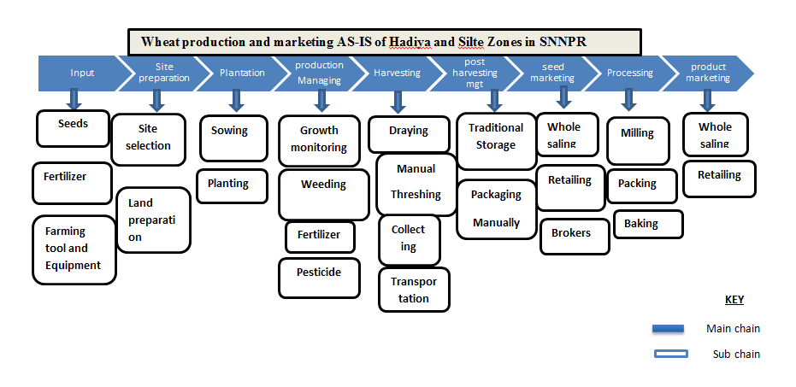

Figure 1. The AS-IS Wheat production value chain

**Benchmarking:** It is a standard, or a set of standards, used as a point of reference for evaluating the performance level of quantity. Benchmarks may be drawn from a country's own [experience](http://www.businessdictionary.com/definition/experience.html), from the experience of all sectors in the other country. The benchmark was selected based on the total production and productivity (yield) history of countries. The following table shows the total production and productivity of the world's top wheat producers in production and yield including our country Ethiopia.

**Table 6 Total production and yield of Wheat in the world**

|  |  |  |  |  |
| --- | --- | --- | --- | --- |
| Rank | Country | Production (Tons in million) | Area (Hectare in million) | Yield (tons/hectare) |
| 1 | China | 133.6 | 23.7 | 5.64 |
| 2 | India | 103.6 | 29.3 | 3.54 |
| 3 | Russia | 74.5 | 27.5 | 2.71 |
| 4 | USA | 52.5 | 15 | 3.50 |
| 5 | Pakistan | 24.3 | 8.7 | 2.79 |
| 6 | Iran | 16.8 | 8 | 2.10 |
| 7 | Egypt | 9 | 1.41 | 6.38 |
| 8 | Ethiopia | 5.3 | 1.78 | 2.98 |
| 9 | The Netherlands | 1.13 | 0.12 | 9.42 |
| 10 | Ireland | 0.6 | 0.063 | 9.52 |
| 11 | Zambia | 0.15 | 0.022 | 6.82 |

(Source: USA Dep’t of Agri, 2021)

The above countries also differ in their productivity rate. Considering the amount of total world wheat production India is the largest producer with 133.6 million tons, and India comes second with 103.6 million tons. Whereas considering yield, Ireland is the top country with 9523.81 kg/hectare and The Netherlands with 9416.6 kg/hectare comes second. The following figure also shows productivity rate of these wheat producing countries in Tons per hectare in order of their importance.

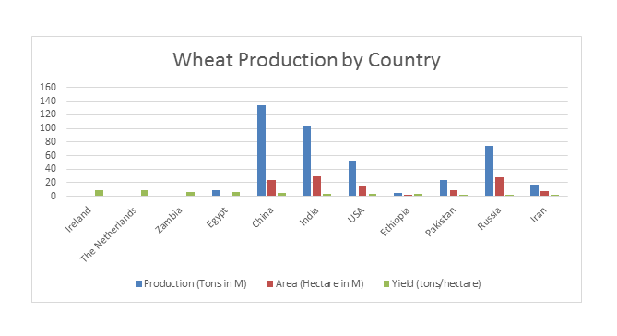Source USA Dep’t of Agri 2021

Figure 2 Productivity rate of world wheat-producing countries in quintals per hectare

To select a benchmark country, we considered the total production and yield amount of a given country that is higher than that of Ethiopia. In Africa, Egypt is the only country that scores both higher production and yield per hectare compared to the US. In the world, including Egypt, India, and the USA score more production and yield amounts compared to Ethiopia. Egyptian wheat farming is more focused on the irrigation system, whereas Indian wheat farming employs both rain-fed and irrigation systems. In the case of Ethiopia, we have a mainly rain-fed agriculture system with a little irrigation system.

**Wheat production potential in different parts of Ethiopia:** The Ethiopian government, through the Agricultural Growth Program, is active in efforts to improve the production and productivity of wheat to increase the domestic supply. The International Food Policy Research Institute (IFPRI), established in 1975, provides evidence-based policy solutions to sustainably end hunger and malnutrition and reduce poverty. Because Ethiopia traditionally produces wheat and has low productivity. Ethiopia is the largest wheat producer in Sub-Saharan Africa and has a favorable wheat growing climatic environment to produce enough amount of wheat for household consumption, industry input, and also for export, to ensure food security for our country, and to ensure significant production potential.

**Area, Production, and Yield of Crops for Private Peasant Holdings**

**Table 7 Regional production rate**

|  |  |  |  |  |
| --- | --- | --- | --- | --- |
| Area | Area in hectare | Production | Yield | Percent |
| Ethiopia | 1,897,405.05 | 57,801,305.96 | 30.46 |  |
| AMHARA | 641,170.34 | 18,152,556.60 | 28.31 | 31.4% |
| North Gondar | 33,086.71 | 811,196.56 | 24.52 |  |
| South Gondar | 70,448.50 | 1,979,937.08 | 28.10 |  |
| North Wollo | 51,771.09 | 1,178,983.87 | 22.77 |  |
| South Wollo | 95,657.15 | 535,726.12 | 21.29 |  |
| North Shewa | 130,442.1 | 3,920,778.54 | 30.06 |  |
| East Gojam | 147,694.69 | 4,743,813.86 | 32.12 |  |
| West Gojam | 52,677.96 | 1,611,676.46 | 30.59 |  |
| Waghumer | 11,855.50 | 173,931.8 | 14.67 |  |
| Central Gonder | 33,653.94 | 848,150.94 | 25.2 |  |
| OROMIA | 996,364.40 | 32,877,497.09 | 33 | 56.88% |
| Jimma | 29,257.00 | 918,793.83 | 31.4 |  |
| West Shewa | 71,351.01 | 2,362,113.80 | 33.11 |  |
| North Shewa | 73,568.14 | 2,110,602.88 | 28.69 |  |
| East Shewa | 113,038.75 | 3,751,494.28 | 33.19 |  |
| Arsi | 209,433.14 | 7,200,170.94 | 34.38 |  |
| Wast Harerge | 1,312.26 | 23,988.93 | 18.28 |  |
| East Harerge | 13,606.84 | 245,775.18 | 18.06 |  |
| Bale | 129,121.39 | 4,561,911.12 | 35.33 |  |
| South-West Shewa | 72,741.68 | 2,291,792.78 | 31.51 |  |
| Horo Guduru Wollega | 27,337.41 | 891,584.57 | 32.61 |  |
| West Arsi | 120,724.14 | 4,183,076.57 | 34.65 |  |
| Buno Bedele | 1,751.16 | 49,907.88 | 28.5 |  |
| Finfinne Zuria | 35,352.3 | 1,075,243.73 | 30.42 |  |
| East Bale | 67,061.24 | 2,340,444.76 | 34.9 |  |
| SNNP | 147,640.62 | 4,316,813.66 | 29.24 | 7.468% |
| Guraghe | 29,298.46 | 887,908.62 | 30.31 |  |
| Hadiya | 36,740.13 | 1,085,579.81 | 29.55 |  |
| Kembata Tembaro | 13,105.45 | 386,115.98 | 29.46 |  |
| Wolayita | 2,470.16 | 71,556.81 | 28.97 |  |
| Kefa | 7,486.49 | 214,147.49 | 28.6 |  |
| Gamo Gofa | 18,918.7 | 509,884.13 | 26.95 |  |
| Yem Special Woreda | 2,823.3 | 82,624.23 | 29.27 |  |
| Dawro | 1,636.14 | 45,007.57 | 27.51 |  |
| Siltie | 29,709.39 | 888,735.88 | 29.91 |  |
| Halaba | 2,353.08 | 71,052.11 | 30.2 |  |
| Tigray | 102,258.28 | 2,239,071.83 | 21.9 | 3.87% |
| Centeral Tigray | 7,097.77 | 154,950.83 | 21.83 |  |
| Eastern Tigray | 31,969.99 | 730,799.49 | 22.86 |  |
| Southern Tigray | 27,570.45 | 570,116.53 | 20.68 |  |

*(Source, Central Statistical Agency, 2013 E.C)*

**Wheat Production Value Chain Benchmark:** Benchmark is a standard, or a set of standards, used as a point of [reference](http://www.businessdictionary.com/definition/reference.html) for evaluating [performance](http://www.businessdictionary.com/definition/performance.html) or level of [quality](http://www.businessdictionary.com/definition/quality.html). Benchmarks may be drawn from a country's own [experience](http://www.businessdictionary.com/definition/experience.html), from the experience of all sectors in the other country.

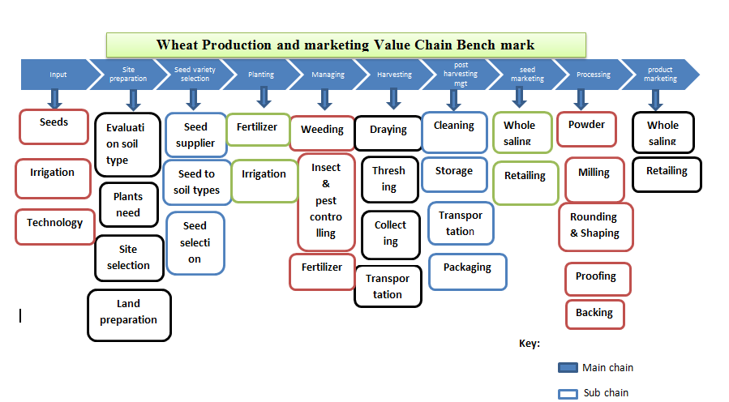

Figure 3: Wheat production and value chain benchmark

**Gap Identification between AS-IS and Benchmark**

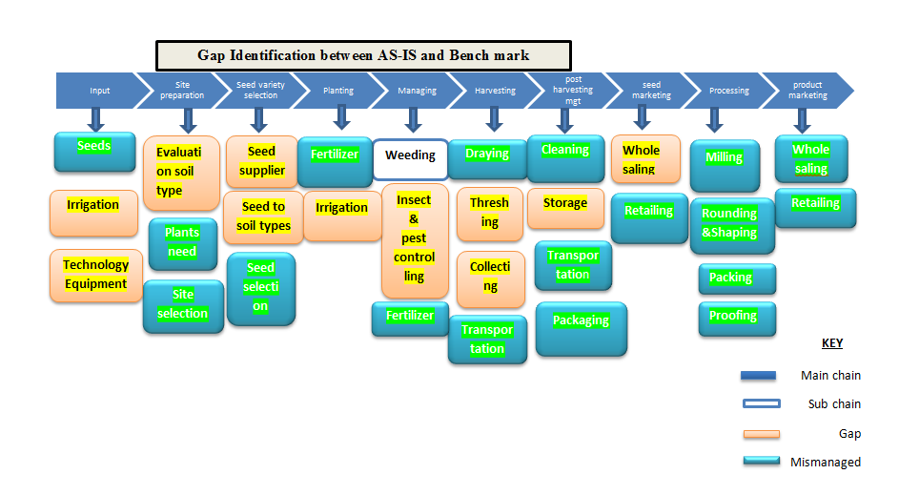

Figure 4: Gap between AS-IS and benchmark

**Comparative Analysis (wheat production and marketing):** The process of analyzing the value chain activities is according to the four parameters (Yield, Quality, Cost, and Time) to identify the Gaps between AS-IS compared to the Benchmark (TO-BE). The four parameters are defined as flows:

* **Yield:** Itrefers to level or number of outputs acquired. In our case wheat productivity rate in tone per hectare.
* **Quality:** It refers to the level of standard applied. In this case, we look at the quality of each group by observing the level of export (To-Be) and the acceptance level of AS-IS to the nearby factories.
* **Cost:** Itrefers to the amount of money allotted in a specific activity. In this case we determined the amount of money required to farm a hectare of land with wheat production.
* **Time:** Itrefers to the specific duration, time limitation in performing the activities. In this case we determined the time required to farm a hectare of wheat land.

**Table 8: Comparative analysis of wheat production**

|  |  |  |  |  |
| --- | --- | --- | --- | --- |
| Four parameters | AS-IS | To Be (bench mark) India | Difference | Remark |
| Yield | 2.98 | 3.54 | 0.56 | Tones/hectare |
| Cost | 25,384.04 birr (493.84 USD | 20,555.19 birr(399.88USD) | 4,828.84 birr(93.94USD) | Total cost per hectare |
| Quality | Medium | High (exported) |  |  |
| Time | 120-130 days | 110-130 days |  |  |

Source: Authors' field survey (2024)

**Description of constraints in the AS-IS value chain relative to the benchmark**

**Table 9: Input supply**

|  |  |
| --- | --- |
| **Function** | **Problem** |
| **Seed: -** Besides, the use of local varieties | * Shortage of improved seeds * Use of Sub-standard/unspecified seed varieties * Skill gap in seed preparation * Lack of convenient cold storage rooms |
| **Fertilizer: -** Use of organic and inorganic fertilizer or compost,parchment, wood ash, soil& any animal dung materials can be used for compost preparation. | * An inappropriate ratio of components * An inappropriate composition of ingredients * Poor integration between producers & processors * Inadequate storage for compost |
| **Farm tools:** - Use of manual tools | * Reduced productivity due to manual operation * Transmission of wheat disease due to untreated hand tools * Poor weed control * Tiresome (time-consuming) * Poor quality of farm tools * A poor linkage between producers & farm tool suppliers |

Source: Authors' field survey (2024)

**Table 10: Land preparation**

|  |  |
| --- | --- |
| Function | Problem |
| Site selection: - a place rich in decomposed plant pieces  sufficient rain distribution | * Inappropriate slopes on the selecting areas * Poor fertility * Deficiency in the required nutrients and minerals * Poor treatment of soil * Frost action and impacts |
| Clearing: - Site clearing by slashing | * Tiresome & time taking manual work * Unsafe operation with hand tools |
| Laying out: - Laying out is carried out by using hand tools such as tape rule, line level & pegs | * shortage of appropriate hand tools * Lack of surveying materials * Skill gap on laying out &levelling |
| Plowing: - it involves tilling and turns over outer and inner soil layers for coffee planting | * No ploughing practice or trend before holing among produces in the study area |
| Fertilizing: -   * Use of organic fertilizer or compost twice per year * Use of locally available materials such as green leaf, crop residue, animal manure, biomass wood ash soil & any biodegradable materials can be used for compost preparation. | * Some produces don’t use fertilizers periodically (twice a year) * Some produces use un-decomposed or sub-standard compost * Some produces don’t use the recommended amount (3-5kg per plant per round) application of compost without considering the age of the wheat as well as a round of practicing |
| Soil and water conservation: - it involves a construction of structures such as a trench, micro-basin, pet and tie ridges, etc | * practicing soil & water conservation after seeding rather than before * low-quality structures that may facilitate erosion rather than be conserving soil and water |

Source: Authors' field survey (2024)

**Table 12: Role and responsibilities of actors and stakeholders**

|  |  |  |
| --- | --- | --- |
| **No.** | **Actors/Stakeholders** | **Responsibility** |
| 1 | Central Region Agricultural & natural Resource Development Bureau | * EvEvaluate, screen, and adopt value chain study results done by the concerned organizations (by the Science and Information Technology Bureau). * Develop manuals (by focusing on benchmark, India) on the productivity and marketing of wheat and transfer them to lower structures (zones and Woredas) * Provide training on the manuals * Disseminate identified feasible technologies to stakeholders not only in to study area but also scale up to all potential areas in southern Ethiopia and frequently follow up. |
| 2 | Hadiya and Silte zone agricultural and natural resource management department | * Adopt manuals transferred from higher structure and support Woreda agricultural offices and extension agents at the kebele level * Facilitate the easy availability of seed and chemicals at the local level * Disseminate technologies to stakeholders by providing support to experts and tomato producers |
| 3 | Lemu Woreda and Sankura Woreda, the agricultural and natural resource management office, and the Woreda administration | * Give focus on challenges that limit wheat production like inputs (fuel, fertilizers, finance, and land for youth and women participation) * Create awareness (extension services), continuous follow-up & build capacity for the problems that producers suffer from |
| 4 | Central Agricultural Research Institute  (SARI) | * Provide improved seed varieties that resist diseases, * Research agronomic practices and the economic efficiency of wheat production. |
| 5 | Universities | * Identify gaps & deliver training on the skill gap of the wheat value chain and related issues * Evaluate this and other studies done for the sector * Adopt and disseminate those studies to the societies through different communication methods * Work cooperatively with TVET and other sectors to intervene on the technology gap |
| 6 | ATA | * Design and transfer wheat production identified feasible seed preparation |
| 7 | TVET colleges | * Identify technologies in the value chain; prepare an action plan on which and when technologies to be transferred; transfer the feasible technologies * Identify gaps, prepare a module, and deliver training on kaizen & entrepreneurship based on the level. |
| 8 | Trade & market development offices | * Create market linkage for the smallholder farmers & collectors engaged |
| 9 | Agricultural marketing and the cooperative sector at the zonal and Woreda levels | * Work on strengthening the existing tomato-producing cooperatives and re-establishing new ones |
| 10 | South region science & information technology bureau & lower structure offices | * Create a technology transfer framework and build capabilities in technological learning, adaptation, and utilization through searching, selecting, and importing effective technologies * Work cooperatively with TVET and other sectors to intervene on the technology gap * Work with all stakeholders |

Source: Authors' field survey (2024)

**5. CONCLUSION AND RECOMMENDATIONS**

This study, titledbenchmarking and enhancing the wheat value chain in Central Ethiopia: A comparative assessment with global best practices, employed a structured value chain analysis using four key performance parameters; yield**,** quality**,** cost**,** andtime to evaluate the current system (*AS-IS*) and identify gaps in comparison to international best practices (*TO-BE*). This approach enabled a comprehensive assessment of inefficiencies and opportunities within the wheat value chain in the study area.

The findings revealed critical determinants influencing value chain performance. These socio-economic and institutional variables are strongly linked to inefficiencies observed across the four analytical dimensions:

* **Yield**: Productivity levels were found to be below benchmark standards due to limited access to modern farming techniques and agronomic support.
* **Quality**: Post-harvest handling practices and inconsistent grain standards contributed to lower product quality compared to global norms.
* **Cost**: High input costs and inefficient supply chains increased production and marketing expenses, reducing competitiveness.
* **Time**: Delays in accessing inputs, processing outputs, and reaching markets extended the overall production and distribution cycle.

Bridging these AS-IS vs. TO-BE gaps is essential for building a robust and competitive wheat value chain. A strengthened chain can significantly enhance productivity, quality, market access, and rural livelihoods in Central Ethiopia.

Based on these insights, the following targeted recommendations are proposed:

* **Improve Yield through Knowledge and Input Access**: Expand extension services and promote the adoption of high-yielding varieties and improved agronomic practices to close productivity gaps.
* **Enhance Quality Control Mechanisms**: Invest in post-harvest infrastructure, training in quality standards, and enforcement mechanisms to align product quality with market expectations.
* **Reduce Costs through Supply Chain Optimization**: Encourage collective purchasing, reduce transaction costs, and improve efficiency through digital platforms and cooperative systems.
* **Shorten Time to Market**: Improve infrastructure and streamline processes in input distribution, processing, and logistics to reduce turnaround time along the chain.
* **Increase Access to Market Information and Off-Farm Income Opportunities**: Equip farmers with timely, accurate market data and promote income diversification to strengthen market engagement and resilience.
* **Design Inclusive Interventions**: Consider the socio-economic profiles of farmers such as marital status and household structure to ensure interventions are inclusive and locally appropriate.

Collaboration among stakeholders including government institutions, NGOs, cooperatives, and private sector actors is critical in closing the identified performance gaps. Drawing on global benchmarks provides a roadmap for strategic improvement. Lastly, further research is recommended to extend this benchmarking framework to other regions and commodities, ensuring a broader evidence base for national value chain development policies.

**DISCLAIMER (ARTIFICIAL INTELLIGENCE)**

The author hereby declares that generative AI technologies such as Large Language Models have been used during the editing of the manuscript. The details of the AI usage are provided below:

1. Name and Source of Generative AI Technology: ChatGPT, developed by OpenAI

2. Version and Model: GPT-4-turbo, April 2025 release

3. Input Prompts Provided to the AI:

* Language editing of this manuscript.
* Please improve grammar, coherence, and flow in the attached academic paper
* Polish the language while preserving the original structure and meaning.

The AI was used solely for language enhancement, including grammar correction, clarity improvement, and academic tone refinement.

**DECLARATION OF CONFLICTS OF INTEREST**

The authors declare that there is no conflict of interest regarding the publication of this paper.

**Refrences**

Amentae, T. K., Hamo, T. K., Gebresenbet, G., & Ljungberg, D. (2017). Exploring wheat value chain focusing on market performance, post-harvest loss, and supply chain management in Ethiopia: The case of Arsi to Finfinnee market chain. Journal of Agricultural Science, 9(8), 22.

Anteneh, A., & Asrat, D. (2020). Wheat production and marketing in Ethiopia: Review study. Cogent Food & Agriculture, 6(1), 1778893.

Deribe, Y., Getnet, B., Kang, T. G., & Tesfaye, A. (2021). Benchmarking the status of agricultural mechanization in Ethiopia (Research Report No. 133). Ethiopian Institute of Agricultural Research (EIAR).

Effa, K., Fana, D. M., Nigussie, M., Geleti, D., Abebe, N., Dechassa, N., Berisso, F. E. (2025). The irrigated wheat initiative of Ethiopia: A new paradigm emulating Asia’s green revolution in Africa. Environment, Development and Sustainability, 27(1), 2161–2186.

Falola, A., Achem, B. A., Oloyede, W. O., & Olawuyi, G. O. (2017). Determinants of commercial production of wheat in Nigeria: A case study of Bakura Local Government Area, Zamfara State. Trakia Journal of Sciences, 15(4), 348–355.

Ferede, S., Legese, W., Fitta, T., Jaleta, M., Badebo, A., Abeyo, B., & Aliy, S. (2010). Integration of smallholder farmers into the durum wheat value chain: Achievements, challenges and lessons learned. Lessons from the Wheat Seed Scaling Project, Ethiopia.

Minot, N., Warner, J., Lemma, S., Kasa, L., Gashaw, A., & Rashid, S. (2019). The wheat supply chain in Ethiopia: Patterns, trends, and policy options. Gates Open Research, 3, 174.

Shiferaw, W., Abinasa, M., & Tadesse, W. (2020). Evaluation of bread wheat (Triticum aestivum L.) genotypes for stem and yellow rust resistance in Ethiopia. Computational Biology and Bioinformatics, 8(2), 43–51.

Spielman, D. J., Byerlee, D., Alemu, D., & Kelemework, D. (2010). Policies to promote cereal intensification in Ethiopia: A review of evidence and experience. Food Policy, 35(3), 185–194.

Udhayan, N., Naik, A. D., & Hiremath, G. M. (2023). Value chain analysis of wheat in North Karnataka, India. International Journal of Plant & Soil Science, 35(20), 974–979.

Yirga, C., Rashid, S., Behute, B., & Lemma, S. (2019). Pulses value chain potential in Ethiopia: Constraints and opportunities for enhancing exports. Gates Open Research, 3, 276.