**“A study of promotional activities by retail stores and their impact on consumer retail preferences”**

**By**

**Dr. Anil R. Pande**

Assistant Professor

Jamanalal bajaj Institute of Management Studies,

University of Mumbai

anilpande@jbims.edu

**Abstract**

**Dr. Anil R. Pande**

Assistant Professor

Jamanalal bajaj Institute of Management Studies,

University of Mumbai

anilpande@jbims.edu

This research study is undertaken to find out and understand various promotional activities undertaken by retail houses and stores, and also to find out their impact on the purchasing behavior of consumers at retail stores and preferences of consumer towards stores. Supermarkets and convenient these days have grown rapidly in India. They have replaced traditional distribution centers of various stocks. How those stores retain and gain customers is a very important subject of study. With the advent of online shopping sites, wide range of product categories by online sellers and easy availability of almost all products, it becomes very important for retails to bring customers back to their stores and increase the footfall in their stores. One of the many ways which supermarket chains entice customers into their stores is by way of promotions. Stores typically promote the products they have for sale but stores will also promote themselves. Hence, the very objective of this study to examine how Retail outlets use promotions and what affect those promotions have had on customers regarding their store preference.

Key Words: *promotional activities, purchase behavior, attitude, supermarkets, retail outlets*

**Introduction:**

Many supermarkets offer the same type of or similar products at the same or similar prices, so it becomes necessary for businesses to stand out from each other so that they can maximize profits. Various means of marketing are employed to attract customers and as promotion in this regards plays a major part. Hence, it is necessary for researchers, business decision makers to understand which promotional activities in retail stores contribute to higher foot fall, higher revenue, more loyalty towards retail stores and more preference for retail stores. Due to surge in online shopping and its obvious advantages supermarkets, these days, retailers are trying to entice consumers into supermarkets and get them to make purchases. Therefore, now it is more important for retailers to bring out and understand which promotional activities have positive impact on the consumer purchasing behavior and how consumers rank promotions activities of the retailers. Knowledge of how customers rank promotions relative to each other and how those promotions affect consumers can be useful in deciding which promotions made need to be altered and which promotions should be used more frequently.

In recent years, supermarkets and convenient stores have grown rapidly in Indian land, replacing the traditional distribution centers of Indian land. With many of the main supermarket stores within Indian land still planning growth despite the recent economic downturn, how those stores plan to keep and gain customers is a very important subject of study. With the drop in consumer spending during the economic downturn, stores have had to work harder to bring customers into their store and to get consumers to spend. One of the many ways which supermarket chains entice customers into their stores is by way of promotions. Stores typically promote the products they have for sale but stores will also promote themselves. The different promotions which stores run all affect consumers in various ways and to varying degrees. It is the intent of this research study to examine how Retail outlets has used promotions and what affect those promotions have had on customers and customer behavior. While the concepts of this research study should be applicable to businesses in general, this research study will be conducted on the most successful supermarket chain in Indian land, Retail outlet. By focusing on the most successful of the three major supermarket chains in Indian land, this study intends to analyze which of Retail outlet’s promotion methods most affects consumer purchasing behavior and which of Retail outlet’s promotions only marginally affect consumer purchasing behavior.

**Research question:**

* Whether more customers based promotion results into more footfalls in Supermarket?

Thereby more loyal consumers?

**Purpose of the Study:**

This research study attempts to analyse various forms of promotions by retailers and tries to understand how those promotion methods affect consumers and their behavior. Membership rewards, mailings, pricing, and other methods of promotion at Retail outlets are analyzed so that the effects of those promotions on consumers and on consumer purchasing behavior can be better understood.

The very purpose of this study is to gain a deeper understanding of promotion methods and to analyze promotion methods as they have been applied at and by supermarket stores. Furthermore to find out most influential promotional strategies which influence the purchasing behavior of customers at Retail outlets?

**Research Objectives:**

The objectives of this research study are as follows:

1. To study various forms of promotion that affect consumers and consumer behavior

2. To evaluate how consumers rank different forms of promotion relative to each other

3. To find best forms of promotion that attracts the customers more.

**Scope of the study:**

This research project is designed to discover the various promotion methods employed by Retail outlets and the affect those promotion methods have on consumers and consumer behavior. The datafor this research project is collected in from Mumbai suburbs. Prime focus of the study is on promotional activities by only retailer and in Mumbai suburban area.

**Literature review:**

The models currently exist for promotion is the AIDA (Attention, Interest, Desire, and Attention Model) model, also known as the persuasion model and the involvement model. These two models describe two methods that help with the outlining and achievement of promotional goals by companies. The means by which these promotions are employed vary with different sales promotions and advertisements can help to achieve the promotional goals as a part and alongside sales promotions.

AIDA model is an acronym for what promotional activities aim to draw from customers: attention, interest, desire, and action. Since it is necessary for a customer to know a product exists before considering purchasing the product, gaining the attention of the target market is the first major goal of many promotional campaigns. Once attention of consumers is attracted, the next step in the AIDA model is the sparking of interest in a product by demonstrating features, usesage and benefits of the product. Next, desire in the product must be stimulated by displaying product superiority and the ability of the product to specify needs. The final step in the AIDA model is the push of the customer towards the final action of purchasing the product (Ferrell & Hartline, 2008).

The Involvement model, “only after taking the action of trying and using a product do people begin to take serious note of its advertising and form any attitude towards it” (Cummins, 1998). In the AIDA model, the consumer is persuaded into action after being made aware of the product and having interest and desire in the product sparked. With the involvement model, the customer first takes action by using a product and after being involved with the product, comes to take notice of ads and other means of promotion before developing an attitude for the product (Cummins, 1998).

**Summary of Literature review:**

|  |  |
| --- | --- |
| Authors | Statements |
| Cummins, 1998 | People take serious note of its advertising and form any attitude towards it after using the product. |
| Cummins, 1998 | With the involvement model, the customer first takes action by using a product and then take notice of ads and other means of promotion before developing an attitude for the product. |
| Ferrell & Hartline, 2008 | Advertising is paid, non-personal communication transmitted through media such as televisions, radio, magazines, newspapers, direct mail, outdoor displays, the internet, and mobile devices. |
| Assael, 1998 | Attitudes are learned predispositions towards an object or class of objects in a consistently favorable or unfavorable way. |
| Blythe, 1997 | It is not a behavior, it is a predisposition towards a particular behavior. |

**Fishbein’s multi-attribute model:**



To explain the link between attitudes and behavior, Fishbein modified his multi-attribute model and developed the theory of reasoned action. The theory of reasoned action postulates “that to predict behavior more accurately, it is more important to determine the person’s attitude to that behavior than to the object of behavior” (Assael, 1998,). Therefore, what a contest offered would matter less to the success of a contest promotion than the fact that a contest was in progress. The theory of reasoned action also defines beliefs as the perceived consequences of an action rather than the perceived attributes of an object.

**Research Methodology:**

A structured questionnaire instrument was designed by using the the above stated variables and administered to the consumers of retail malls. The sampling design was a random sampling and the questionnaire was majorly on the demographic profile of the consumer to understand the association and effect of this demographic profile on the preferences of store with promotion.

Random sampling method was used and the data was collected. The sampling size for this study was 51. The data so collected is analyzed by using bar charts, pie charts and on percentage and proportions.

**Some major findings:**

* Total sample size was 51, done in Big Bazar and D-mart and reliance mart, where 56.9% male participated in this survey and 43.1% females participated and they shared their views on this purchase or buying behavior.
* Age wise, 62.3% fall in 20-30 years and 31.4% of respondents were 30-40 years of age.
* Major part of the Paid Employees has taken part of the survey and secondly house wives who visited to shop in the retail outlet and to share their views on promotion activity.
* More than 49% of the people shop twice in the month and 30% of the respondents shop only once in the month, and there are 21.6% who said that they shop for thrice or more.
* More than 60% of respondents have said that they see promotional board which placed in the retail outlets. And ¼ of the people said they don’t see any promotional boards or activity in the retail outlets.

Below are the ranking for promotion activity by respondents.

|  |  |
| --- | --- |
| Promotional activities | Ranking |
| Buy on get one | 1 |
| Cash back Promotions | 2 |
| Free Trials | 3 |
| Price off Promotions | 4 |
| Membership Programs | 5 |
| Discount coupons | 6 |
| Free Samples | 7 |
| At the counter display | 8 |
| Demonstration | 9 |
| Gift Cards | 10 |

* 44% of Shoppers were agreed to increase their shopping frequency if top 5 offers would be offered to them in the store, where 28% were not ready to increase their shoping frequencies even after getting offers and 28% are potential customer who may or may not visit
* .

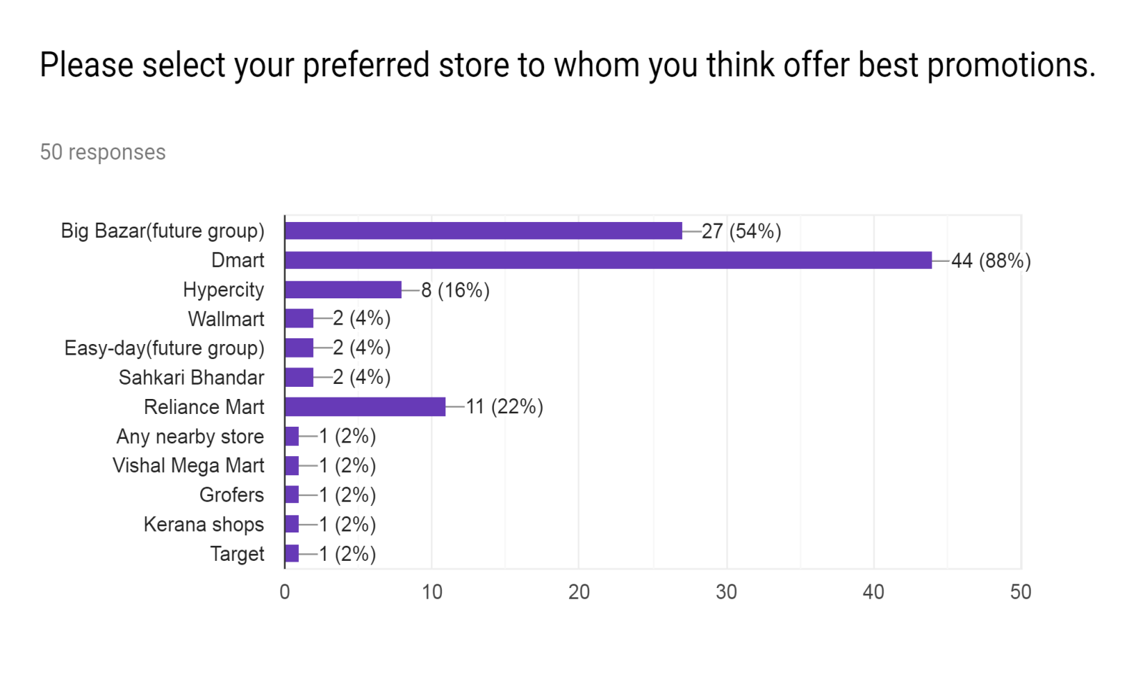

* Top 3 stores in promotional activities and offers it was D-mart with 88% followed by Big bazar & Reliance Mart.

**Conclusions and Recommendations:**

The findings of this research study show that the promotions which Retail outlets currently employs are free samples, brochures, buy-one-get-one free, discount coupon, price-off, at the counter display, membership program, demonstration, cash-back, and bundled free trial promotions. Buy-one-get-one-free promotions are among the most liked and most successful of the promotion methods employed and sweepstakes and at the counter display promotions are among the least liked and least successful of promotions employed, indicating that promotions which are most likely to influence consumer purchasing behavior are promotions which consumers like. The findings also indicate that there are links between demographic characteristics and consumer purchasing behavior.

The research results show that there are correlations between how much a consumer likes a promotion and how likely it is that a promotion will affect consumer purchasing behavior. Therefore, one recommendation regarding promotions is to find ways to give more favorable impressions of promotions such as sweepstakes and demonstrations. The ineffectiveness of sweepstakes and contest promotions is due in part to the fact that consumers are certain they will not win a sweepstakes. Consumers therefore do not bother to compete and do not alter their purchasing behavior just so that they can compete.

Placing coupons for at the counter display promotions at the counter or offering price-off promotions for at the counter display promotions may help to increase the success of at the counter display promotions in provoking sales although they will be aided at this point by other promotion methods

Higher level of enjoyment may translate into a better perception of demonstration promotions and may lead to demonstrations being a more effective means of affecting consumer purchasing behavior.

Cash-back promotions that require the use of credit cards are decently popular but seem to be isolated to certain demographics while their counterpart promotion, cash-back promotions which require a minimum purchase are less successful.

**Bibliography**

* Assael, H.1998. Consumer Behavior And Marketing Action (6th Ed.).
* (Cummins, J. (1998). Sales Promotions: How To Create And Implement Campaigns That Really Work.)
* Marketing Strategy 4th Edition (OC Ferrell, Michael D. Hartline).
* Merriam-Webster Online.(N.D.).
* International Journal Of Applied Research 2017; 3(5): 177-182
* Philip Kotler, Koshy, Jha, Marketing Management
* Ramaswamy And Namakumari, Principles And Practices Of Marketing.