SOCIAL MEDIA MARKETING STRATEGIES: AN ANALYSIS AND SUGGESTIONS

Research paper by
Dr. Anil R. Pande
Assistant Professor
Jamnalal Bajaj Institute of Management Studies
University of Mumbai
e-mail: anilpande@jbims.edu
mobile: 93223998181

And
Anjali S. Dongardive
Research Student (pursuing Msc-Mathemetics)
Sant Gadge Baba University Amaravati.

SOCIAL MEDIA MARKETING STRATEGIES: AN ANALYSIS AND SUGGESTIONS
Dr. Anil R. Pande
Assistant Professor
Jamnalal Bajaj Institute of Management Studies
University of Mumbai

Anjali S. Dongardive
Student (pursuing Msc-Mathemetics)
Sant Gadge Baba University,Amaravati.

Abstract:
Social media marketing can be an effective strategy for your business. Customers today go online to evaluate the product options available to them; they compare the prices and even watch the reviews for better decisions. If firms know who the audience is, where they hang out online and what they are interested in, better and focused online strategies can be developed to reached to the consumers. Companies have realized the potential of online presence and they strive to go close to the consumers by their state of art online presence. The surge in the mobile internet users have made easy for companies to get to know who are their audience and hoe to be effective than the rivals. Websites of the firms try to provide fullest information of the products and services and try to engage the consumers by one or other strategic initiatives.
In this regards, it is apt for the strategist and the decision makers of the firms to relook into their strategies and find the impact of the same on the audience. This analysis also provides the impetus to the firms that which strategies are most effective and what exactly makes consumer engaged to their products and firms.
Key words: social media, online, strategy, website, strategic initiative.

Introduction:
Brand communication and persuasion for the products and services companies rely traditionally on television, radio, print advertising; and now also such companies constitutes a major share in India. With the penetration of internet and exhaustive use of computers, laptops, tablets and smart-phones, Digital marketing has been emerged as a future. Especially with decreasing prices of electronics it has made it very easy for tier 2 and tier 3 cities customers in India to come online. It is well observed and documented from the researched studies that Indian youth and millennial consumers are continuously engaged with their smart-phones. They use it for daily social communication and networking. Online Social media is now having been emerged as an addictive habit. Whether it is current affairs, history, product search and comparison, local business search etc; internet and electronic appliances for use are basic necessities for today’s generation. They just search on Social Media or Google it.
Social Media engagement is day-by-day is making its mark on all. Digital India Initiative, e-commerce Startup boom in India just adds to it. It is very important for a business to allocate its budgets on Digital marketing and digital presence.
According to a study performed by Google in recent past, India will have more than 800 Million Internet users by 2019 of which 80% will be mobile online users. India already has surpassed US in 2015 in terms of active smart phone users (220 M) to become the second largest in the world. A recent report also revealed about 110 Million users use Facebook in India.

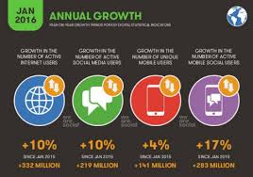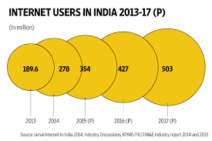
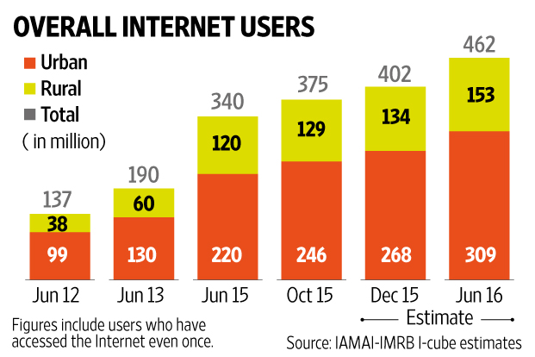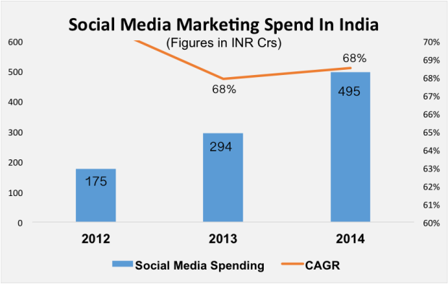
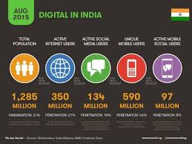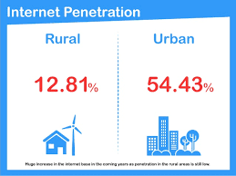
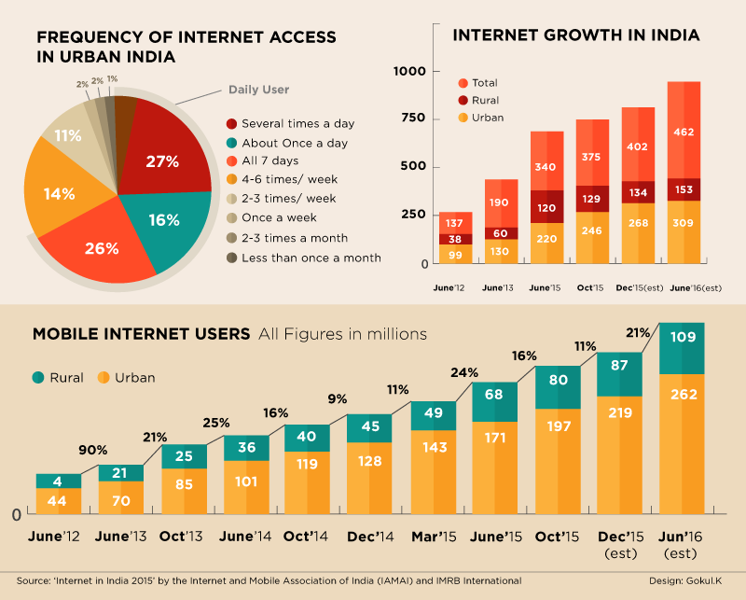

Objectives of the study:
Social media strategies, facilitate interaction with audience members, such as Facebook and Twitter and this can be an important component of a comprehensive communication plan. Social media may be effective as a channel for using commercial marketing techniques to change behavior, also known as social marketing.
The study is undertaken with very specific objectives under consideration as follows.
- To understand and evaluate whether social media marketing strategy helped in directly meeting the businesses’ goals and objectives?
- To focus and understand if the strategy help reach out to the right target audience and location?
- To identify what are the sentiments received and how many users responded.
- To ascertain the type of engagement of user or customer and the rate of engagement

Research Methodology:
Researcher tried to address the questions posed in the objectives of the study by analyzing the variables collected through in-depth study of some articles and blogs. A case study method is applied for analyzing the variables stated below and arrives at conclusion.

Social Media Presence
To understand how prominent the business is on Social Media. Following key performance indicators were taken into consideration. The online questionnaire was sent to the respondents and 67 respondents have given their opinions.

Followers and fans
They are the users who have subscribed to the account, so that they can see the brands content on their feed. Instagram and Twitter see followers, where Facebook business pages will have fans.

Number of mentions
Measuring or counting the number of conversations around the brand on social media.

Reach
Reach is a data metric that determines the potential size of audience any given message could reach. It does not mean that that entire audience will see your social media post, but rather tells you the maximum amount of people your post could potentially reach.

Inbound links
This is in reference to the number of links back to the blog or website the brand receives from quality references

Engagement
Numbers reflecting social media presence are valuable; knowing how engaged the audience actually says a lot more about the success of the social media campaign. The following KPIs offer insight into your engagement levels and will also reveal areas where you could possibly improve – Retweets, likes, comments and shares

Reach and Influence
If a social media post doesn’t get a single like, does it still exist? The following important KPIs will help you measure these areas, and ensure that content doesn’t go unnoticed.
Share Of Voice
    - Share of voice is a metric for understanding how many social media mentions a particular brand is receiving in relation to its competition.
Sentiment
    - “An attempt to understand how an audience feels about a brand, company, or product based on data collected from social media.
Post reach
    - This is the number of users who see a specific social media post.
Number of social influencers
    - With a social media influencer being “a user who can reach a significant audience and drive awareness about a trend, topic, company, or product,” the number of influencers your brand has worked with is a good indicator of popularity and overall success.

Literature Review:
“With a million resources at the click of the button, the consumer is now the focus of marketing campaigns, instead of the product. Consumers are smarter than ever before, continuing on the trend that we’ve seen through history; and don’t respond to obvious product placements; instead, they respond to more authentic forms of marketing.” –Ana Gotter
“The mark of a good marketing strategy is not how many gadgets and neologisms are crammed into it, but how effectively it achieves worthy goals. Therefore, how you define your intent will have a profound impact on whether you succeed or fail.” –Greg Satell
“Social media is not just an activity; it is an investment of valuable time and resources. Surround yourself with people who not just support you and stay with you, but inform your thinking about ways to WOW your online presence” – Sean Gardner
It’s no secret that “word of mouth” has always been considered one of the most powerful forms of marketing for a business. Social media today is the ultimate word-of-mouth marketing. Getting people to connect with you online in the social space helps spread the word about who your company is and your products and services. So there are really two functions of social media for business: 1) Are you participating in the conversation and sharing, and 2) Are you listening and monitoring what is being said about you. – KlintRudolp
Social media marketing can be an effective strategy for your business if you know who your audience is, where they hang out online and what they’re interested in. Getting to know that audience can help you be successful all around–not just on social media but on your website and in your search engine optimization, too – Natasha Gayle
The most powerful social media strategy I’ve seen is connecting with people who share blog posts within your space. For example, I use Twitter’s search to see who shares competing articles, I then network with those individuals and ask them to share my content.
A lot of people will ignore your email, but at least 10% will share your content. It’s an easy way to gain traction to your blog. – Neil Patel

Analysis of Case study: OYO ROOMS
OYO Rooms is an online aggregator of budget hotels in India claiming to be the largest chain of hotels. They partner with hotels giving them customers and keeping a percentage of profits with them. The customer thus can find out hotel stay in city of choice, as per his budget and requirement online, compare with other registered properties and even book it online with or without actual payment
OYO Rooms Business Objectives:
OYO Rooms has one objective, to offer standardized stay experiences at an unmatched price. It adopts hotels to get them in its fold; gets them to follow certain standards of services, features, staff, pricing, security etc. And then sells their rooms under its own brand, for a certain cut. OYO rooms can be booked online using Mobile app. Also they have their presence in all the travel/booking websites.

Social Media Strategy/Approach adopted by OYO Rooms:
To retain its ranking and perform way above the competitors OYO is focused on the mass as well as on digital marketing section aggressively for lead generation and customer acquisition. It has strategized to use all means of social media by targeting potential customers based on their interest, behavior and other parameters which are readily available via digital marketing.
It has strong social media presence on Facebook with over 2.7 lakh fans and a Twitter following of over 8,000 followers. The brand claims to have over 1.5 million app downloads with a good number of active users. To fast track its growth, OYO Rooms organized several campaigns on social media platforms such as:
- Dubsmash Contest
- #AurKyaChahiye videos on Youtube.
- Father’s Day Celebration campaign and IPL Final Verbal Combat.
- Jai Hind was the most successful one that featured Bollywood actor Manoj Bajpai and Raveena Tandon.
- The video fetched over 1 million views to the brand. Some of their recent endeavors area Salute to the heroes of 1965 war and Oyo Explorer – Pune.
Results achieved by Oyo Rooms:
- OYO’s traction and market coverage has swiftly increased because of being listed with travel aggregators like Make MyTrip, Clear trip and com.
- Launch of OYO café, OYO We for Women travelers and OYO Premium for high-end customers.
- Tie-ups with major brands such as Airtel for wi-fi support, ZO rooms, Thomas Cook, Air Pegasus and Tourism and Hospitality Skill councils.
Findings of case analysis:
Along with expanding its business and numbers, OYO needs to pay attention to Customer feedback and reviews as it’s the service offering industry. Also it needs to bring in more stringent offline quality control mechanisms on-board to manage customer experience and keep the brand growing.

Conclusions & Recommendations:
The best way to evaluate social media marketing strategies in a business is to realize the importance of social media in everyday life of people who are likely to become your customers. Social media marketing has become a necessity, one that is imposed to the business by the overall presence and impact social networks have on the users.
In spite of the fact that social media presence has become a necessity, there are numerous ways to leverage social media presence into improving your business, and here are some of the major benefits.
In the world with over 70% of internet users are active on social networks, who spend at least one hour a day on average on those social networks, it proves that social networks have become a sort of reality in which people communicate, interact, and obviously trust. We also have to be aware that over 60% of those users access social networks via mobile devices, with strong indicators that this percent will only increase in the future years.
In such world, we have to admit that social networks are a new dimension of reality that has become a part of the business world as well. Over 90% marketers report they are or will be using social networks for business, while over 60% of them claim to have acquired new customers over social networks.

Bibliography:
- http://www.socialbeat.in/2016/07/19/digital-marketing-industry-report-india-2016/
- http://wearesocial.com/uk/special-reports/digital-in-2016
- http://digiperform.com/5-reasons-why-digital-marketing-is-the-most-promising-career-in-india/
- http://www.langoor.com/in/heres-what-is-in-store-for-digital-marketing-in-india/
- http://www.sas.com/en_us/insights/marketing/digital-marketing.html
- http://www.toprankblog.com/2014/07/digital-marketing/
- http://www.wsiwebsense.com/2016-digital-marketing-concepts/
- http://blog.hubspot.com/marketing/what-is-digital marketing#sm.00i78fxa1103fgc11h11dszh2z9zf
- http://42works.net/internet-marketing/marketing-lessons-that-famous-personalities-have-taught-us-over-the-years/
- http://42works.net/internet-marketing/marketing-lessons-that-famous-personalities-have-taught-us-over-the-years/
- https://blog.kissmetrics.com/50-social-media-influencers/
- http://xcitemediagroup.com/social-medias-role-digital-strategy/
- https://qualbe.com/using-social-media-marketing-digital-strategy/
- https://www.codeinwp.com/blog/social-media-marketing-strategy/
- http://www.samhsa.gov/capt/tools-learning-resources/evaluating-social-media-efforts
- https://blog.hootsuite.com/social-media-kpis-key-performance-indicators/
- http://www.digitalvidya.com/blog/social-media-marketing-case-study-on-oyo-rooms/
- https://www.emarketinginstitute.org/free-ebooks/social-media-marketing-for-beginners/chapter-25-conclusion-importance-social-media-marketing/

